23CSE202 DATABASE MANAGEMENT SYSTEMS
S3 B.Tech CSE
Department of Computer Science and Engineering
Amrita School of Computing, Amritapuri Campus

2. UI Design Document

Group No : C7
Team Members :
Roll No | Student Name
AM.SC.U4CSE25243 | RAJIV A R
AM.SC.U4CSE25249 | SHREYAS RAJESH NAIR
AM.SC.U4CSE25252 | SREERAG TC
AM.SC.U4CSE25206 | ARYAN RAJESH

Project Title :EVENT MANAGEMENT SYSTEM

2.1. Functional requirements:
[list the main functionalities required]
- Secure Dual-Role Authentication Flow: Distinct login validation mapping users to restricted /dashboard/student or /dashboard/admin routes based on encrypted credentials.
- Real-Time Event Discovery & Filtering: A dynamic student catalog supporting search by keyword, and filtering by category (Workshop, Seminar) and availability.
- Optimistic UI Registration & Cancellation: One-click registration that instantly updates the UI (optimistic state) while processing the database transaction in the background, complete with success/error toast notifications.
- Comprehensive Event Lifecycle Management (Admin): Full CRUD (Create, Read, Update, Delete) capabilities for event organizers via a secure, multi-step form modal.
- Live Capacity Monitoring & Export: An admin dashboard featuring real-time statistical readouts (total registrations, sold-out events) and a dedicated mechanism to export participant lists.
- Dedicated "My Events" Management: A specific view for students to track their registered events, view event-day QR codes/tickets, and process cancellations.

2.2. Non functional requirements:
[list the main qualitative features required]
- Enterprise Dark-Mode Aesthetic (Linear/Vercel Style): The system must utilize a hyper-modern, deep dark theme (zinc-900/950 backgrounds) with high-contrast text, subtle glowing borders (fuchsia/cyan accents), and glass-morphic surfaces.
- State-Driven Micro-interactions: Every interactive element must provide immediate visual feedback (e.g., hover scaling, loading spinners inside buttons, skeleton loaders during data fetch) using Framer Motion.
- WCAG Accessible & Responsive: The UI must maintain AAA contrast ratios, support keyboard navigation, and flawlessly scale from 320px mobile viewports to 4K ultrawide monitors using Tailwind CSS Grid/Flexbox.
- Graceful Error Handling & Empty States: The UI must never show a blank screen. Empty queries or zero-state databases must display beautifully illustrated "No Data" components.

2.3. List of AI tools used for building UI(if any):
1. Claude Sonnet 5 medium (for ui build)
2. Gemini Pro Extended (for prompt engineering)

2.4. Prompt (if any) :
Sl. No | Name of the tool | prompts
1 | Claude Sonnet 5 medium | Context: Expert Next.js 14 Developer. Task: Build app/layout.tsx and the global Navbar.tsx. Requirements: 1. Implement a strict "Linear.app" style deep dark mode (bg-zinc-950). 2. Navbar must be sticky, glass-morphic (backdrop-blur-md, bg-zinc-950/50, border-b border-white/5). 3. Left side: CEMS logo with a subtle gradient text (bg-clip-text). 4. Right side: Implement a mock User Dropdown Avatar and a Notification Bell with a red unread badge.
2 | Claude Sonnet 5 medium | Context: Senior UI/UX Engineer. Task: Create app/page.tsx (Authentication/Login). Requirements: 1. A 50/50 split-screen layout for desktop. Left side: An animated, abstract dark gradient mesh (use CSS animations). Right side: Login form centered in a glass card. 2. Form needs a highly stylized toggle switch for "Student" vs "Admin". 3. Inputs must have bg-zinc-900, ring-offset-background, and glow (focus:ring-2 focus:ring-blue-500/50) on focus. 4. Include comprehensive empty-field validation UI states (red text, shake animation) and a Submit button with a loading spinner state.
3 | Claude Sonnet 5 medium | Context: Principal Frontend Engineer. Task: Create app/dashboard/student/page.tsx (Discovery View). Requirements: 1. Implement a layout with a hero greeting ("Welcome back, [Name]") and a stats banner (Events attended, Upcoming). 2. Below hero: A complex filter bar (Search input with magnifying glass, Category Select dropdown, "Available Only" toggle). 3. Render a responsive CSS grid of EventCard components. 4. UX Detail: Include a Framer Motion AnimatePresence so cards smoothly filter in and out. 5. Include a beautiful "No Events Found" empty state component if the filter returns zero results.
4 | Claude Sonnet 5 medium | Context: Frontend Specialist. Task: Create app/dashboard/student/my-events/page.tsx. Requirements: 1. A dedicated view just for the student's registered events. 2. Implement a Tabbed interface ("Upcoming" vs "Past Events"). 3. For "Upcoming" events, display the EventCard but add a "View QR Ticket" secondary button. 4. When the user clicks "Cancel Registration", do not just cancel—trigger a highly styled CancelConfirmationModal (Are you sure? This cannot be undone).
5 | Claude Sonnet 5 medium | Context: Enterprise Dashboard Designer. Task: Create app/dashboard/admin/page.tsx (Overview). Requirements: 1. Sidebar navigation (Overview, Manage Events, User DB). 2. Top section: Three massive metric cards (Total Registrations, System Load %, Active Events) with subtle sparkline charts (use simple SVGs). 3. Bottom section: A "Recent Activity" feed (e.g., "John Doe registered for AI Workshop") mimicking a real-time log. 4. Theme strictly as bg-zinc-950 with zinc-900 elevated cards.
6 | Claude Sonnet 5 medium | Context: Senior React Developer. Task: Build app/dashboard/admin/events/page.tsx (Data Table). Requirements: 1. Create a complex, shadcn-style Data Table displaying all events. 2. Columns: Event ID, Name, Date, Capacity (with color-coded badges for Full vs Open), Status, Actions. 3. Include row-level hover effects. 4. The "Actions" column must have a dropdown menu (three dots) with: Edit, Delete, Export Attendees. 5. Include a global search bar for the table and pagination controls at the bottom.
7 | Claude Sonnet 5 medium | Context: Form UX Expert. Task: Create components/AdminEventModal.tsx (Create/Edit Event). Requirements: 1. A large, beautifully structured dialog overlay (backdrop-blur-xl, bg-black/80). 2. Split the form into two columns (Left: Basic Info like Name, Date, Time. Right: Logistics like Venue, Capacity limit, Description). 3. The Date/Time inputs must look custom, not default browser styles. 4. Include a dynamic character counter for the Description field (e.g., 145/500). 5. Submit button must show a spinning loader while processing.
8 | Claude Sonnet 5 medium | Context: Design System Engineer. Task: Create components/ui/Toast.tsx and integrate it. Requirements: 1. We need a system to show success/error messages in the bottom right corner. 2. Design a Dark Mode toast notification (e.g., "Success: Registration Confirmed"). 3. It must slide in from the right using Framer Motion, stay for 3 seconds, and slide down. 4. Include an X button to dismiss early. Color code the border based on type (Green for success, Red for error, Blue for info).
9 | Claude Sonnet 5 medium | Context: UX/UI Detailer. Task: Create components/LoadingSkeleton.tsx. Requirements: 1. We need to handle database loading states gracefully. 2. Instead of a basic spinner, create a skeleton loader that mimics the shape of the EventCard. 3. It should use bg-zinc-800 and have a continuous, shimmering pulse animation (animate-pulse) across the placeholder title, image block, and text rows. 4. Make it perfectly match the dimensions of the real card.

2.5. List of files:
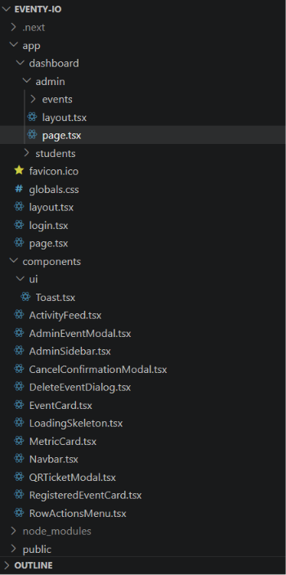

2.6. UI Screenshot:
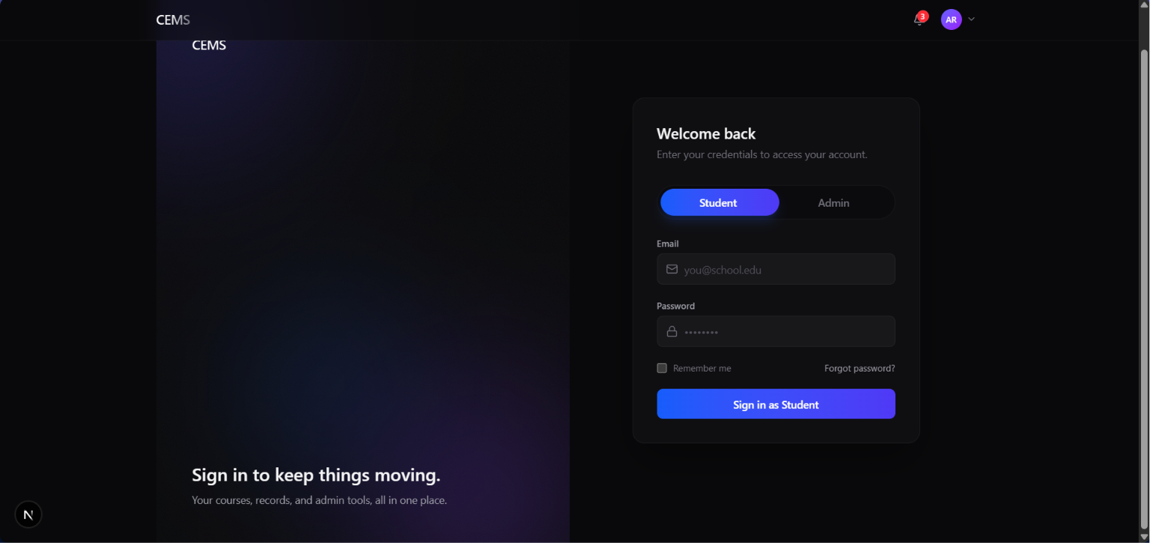
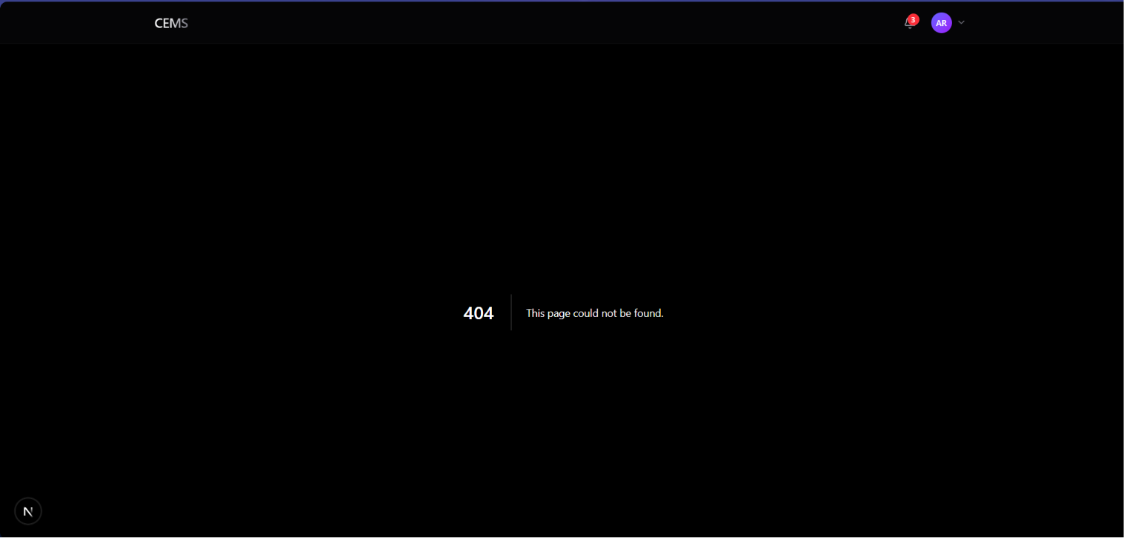
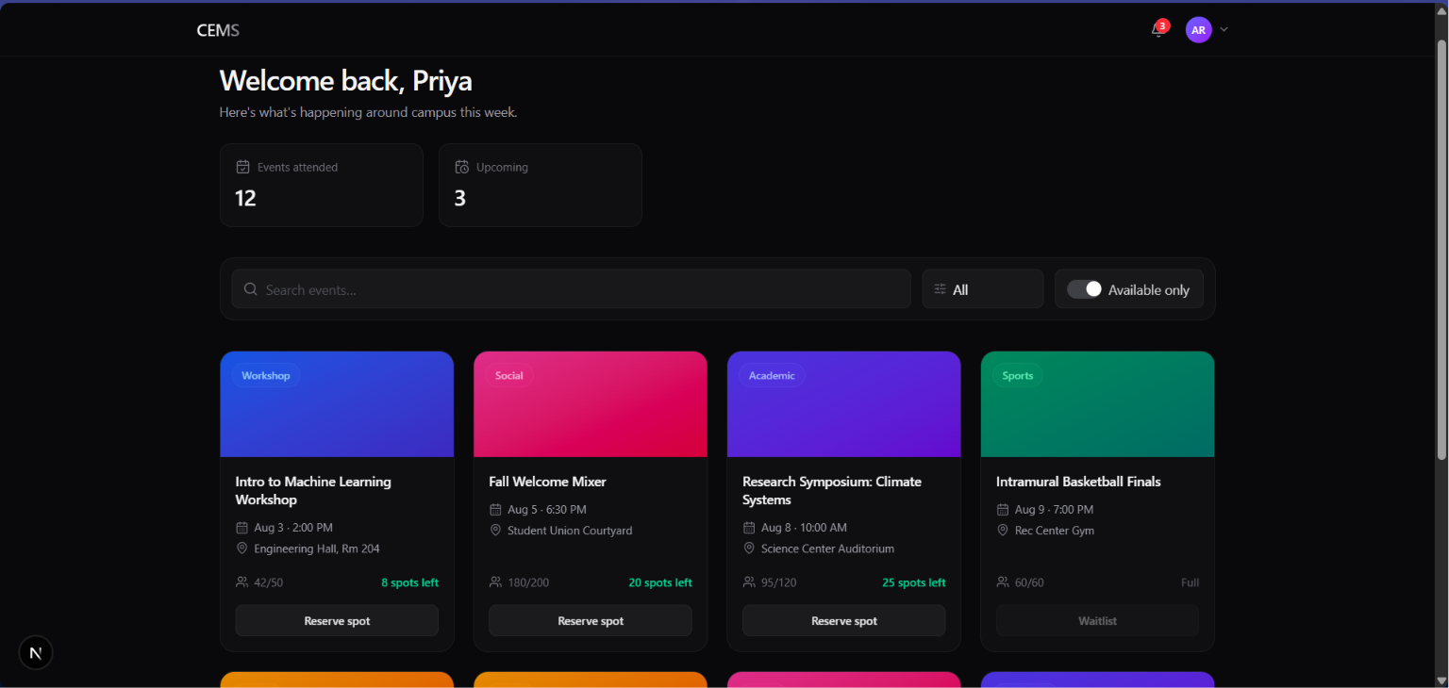
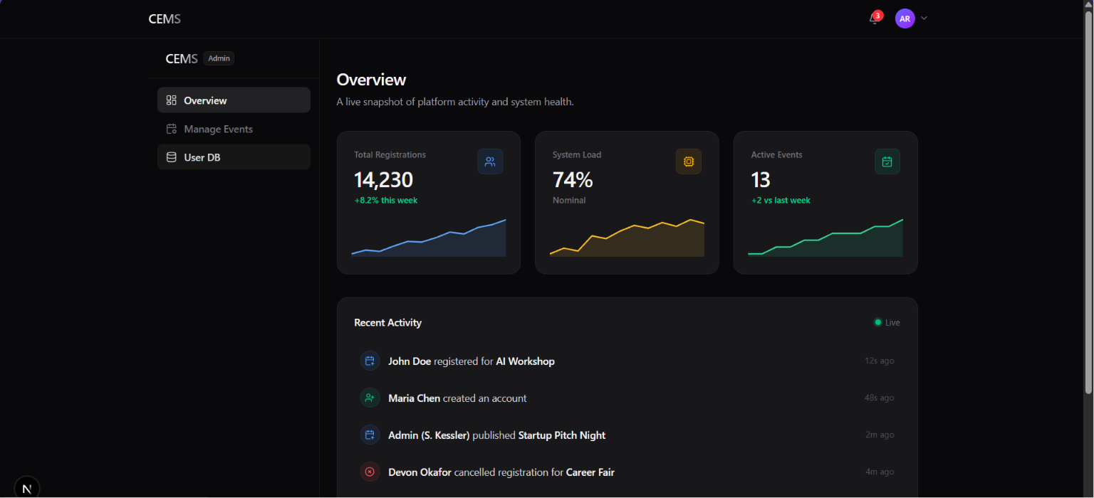
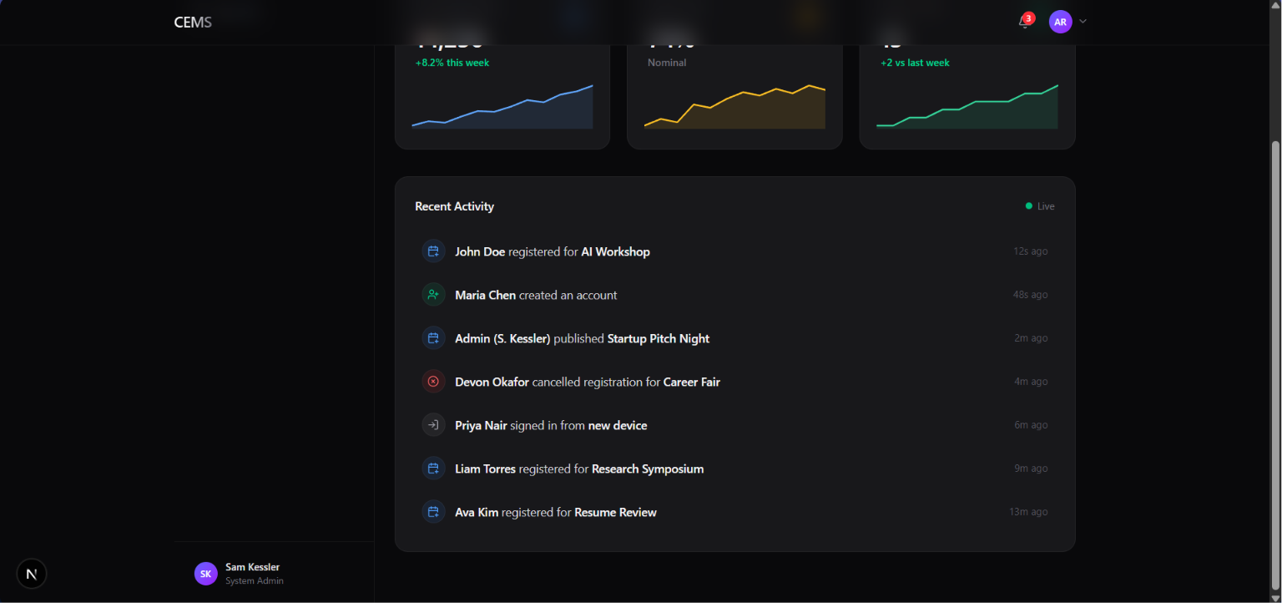

2.7. GitHub Link:
https://github.com/Merlin258/Eventy.io

